

Excel 2010

Pivot Tables

Contents

PivotTables 1

PivotTable datasets 1

Creating a PivotTable 2

Changing the way values are displayed 3

PivotTable Options 5

Grouping data 5

Sorting and Filtering Data 8

Refreshing a PivotTable 9

Formatting PivotTables 9

PivotCharts 10

Creating a PivotChart with a PivotTable 10

Introduction

This workbook has been prepared to help you create a PivotTable report – an interactive table that automatically extracts, organises, and summarises your data. You can use this report to analyse the data, make comparisons, detect patterns and relationships, and discover trends.

This guide can be used as a reference or tutorial document. To assist your learning, a series of practical tasks are available in a separate document. You can download the training files used in this workbook from the IS training web site at: **www.ucl.ac.uk/isd/common/resources**

We also offer a range of IT training for both staff and students including scheduled courses, one-to-one support and a wide range of self-study materials online. Please visit **www.ucl.ac.uk/isd/common/resources** for more details.

# PivotTables

A PivotTable organises and summarises large amounts of data. The data in one or more columns (also known as fields) in your dataset can become row and column labels in the PivotTable. The data in one column is usually chosen for the Values which are summarised in the centre of the table using a specific calculation. It is called a PivotTable because the headings can be rotated around the data to view or summarise it in different ways. You can also filter the data to display just the details for areas of interest.

You can alternatively choose to create a PivotChart which will summarise the data in chart format rather than as a table. Details on creating a PivotChart are set out later in this section.

**The source data can be:**

* An Excel worksheet database/list or any range that has labelled columns. We will use Excel worksheets as examples in this manual.
* A collection of ranges to be consolidated. The ranges must contain both labelled rows and columns.
* A database file created in an external application such as Access or Dbase.

The data in a PivotTable cannot be changed as they are the summary of other data. The data itself can be changed and the PivotTable recalculated thereafter. However, formatting changes such as bold, number formats, etc. can be made directly to the PivotTable data.

## PivotTable datasets

A good dataset for creating a PivotTable will have data organised into columns with a heading at the top of each column. There should be no blank rows in the data so it is all organised into one rectangular block. Each row is a record and each column a field. In the data set on the right, each row represents a stationery order placed by a department.

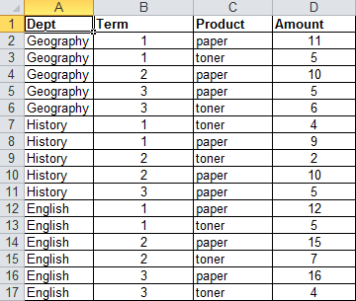

Columns where the values are repeated within the column are ideal for PivotTable row or column labels. So for example, in the dataset on the left, **Dept**, **Term** or **Product** might be placed in the row or column headings. **Amount** might be used as the **Values** to be summarised in the centre of the PivotTable.

#### Example

If **Dept** is used as the row labels, each unique value in that column will appear down the left-hand side of the PivotTable. Similarly if **Product** is used as the column labels then Paper and Toner will appear across the top of the PivotTable. Where a particular value in a row and a particular value in a column intersect, the data in the **Amount** field is summarised in the centre. By default the calculation used is **Sum**. So, for example, where Geography and Paper intersect the total amount of Paper ordered by Geography will be displayed i.e. 26.

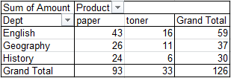

## Creating a PivotTable

1. Click anywhere within the range of data you wish to use to create your PivotTable.



1. From the **Insert** tab select **PivotTable**.  
   Excel will display the Create PivotTable dialog box, automatically select the entire range and add the reference for that range to the Table/Range box.
2. Select **New Worksheet** or **Existing Worksheet** depending on where you want your PivotTable to appear.

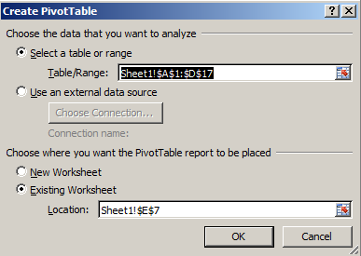

1. If you choose to put the PivotTable into the existing worksheet, you need to make sure you tell the wizard where to place it. The easiest way to do this is to click into an area in the existing spreadsheet. The cell reference will appear in the **Location** box.
2. Click on the **OK** button.  
   A blank PivotTable and PivotTable Field List will be displayed. Two new **PivotTable Tools** tabs become available on the Ribbon: **Options** and **Design**. Any column headings become fields in the **Field List**.

Note that the Field List and additional Tabs on the Ribbon only appear when you click on the PivotTable.

### Arranging your data

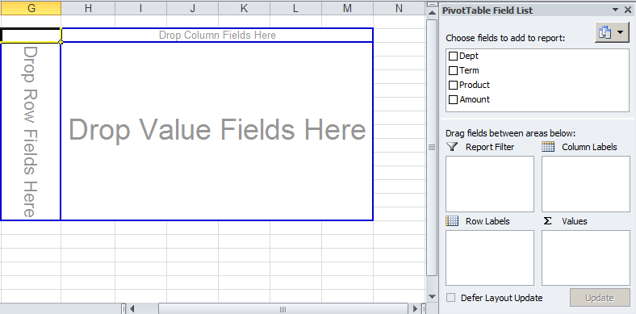

1. From the **Field List**, drag the fields with the data you want to display in rows to the area on the PivotTable diagram labeled **Drop Row Fields Here** or into the **Row Labels box**.
2. Drag the fields with the data you want to display in columns to the area labeled **Drop Column Fields Here** or into the **Column Labels box**.
3. Drag the fields that contain the data you want to summarise to the area labeled **Drop Value Fields Here** or into the **Values** box. Excel assumes **Sum** as the calculation method for numeric fields and **Count** for non-numeric fields.
4. If you drag more than one data field into rows or into columns, you can re-order them by clicking and dragging the columns on the PivotTable itself or in the boxes.
5. To rearrange the fields at any time, simply drag them from one area to another.
6. To remove a field, drag it out of the PivotTable report or untick it in the Field List. Fields that you remove remain available in the field list.

#### Example

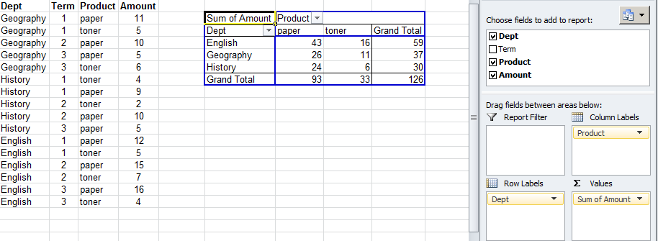

## Changing the way values are displayed

### Changing the way data is summarised



By default, Excel will use a **Sum** function on numeric data and **Count** on non-numeric to summarise or aggregate the data. To change this:

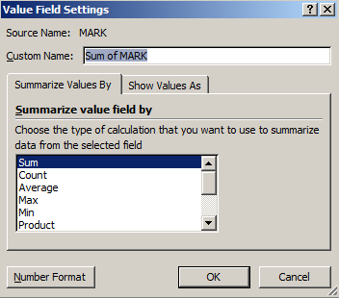

1. Click on the field you want to change (on the PivotTable itself or in the areas below the Field list)
2. Click on **Field Settings** on the **PivotTable Tools Options** tab  
   The Field Setting dialog box will be displayed as shown right.
3. Select the appropriate calculation.  
   For example, change the calculation from **Sum** to **Average** (see below for example).

#### Example

In the example below, the data shows candidate exam results for specific modules (MODCODE), the RESULT each candidate gained, their exact MARK, their grade (UCLGRADE) and the DATE the exam was taken. The PivotTable shows the average MARK for each RESULT for each module so, for example, the average mark that resulted in a Pass (i.e. where Result is P) for module COMPB401 was 70.40909091.

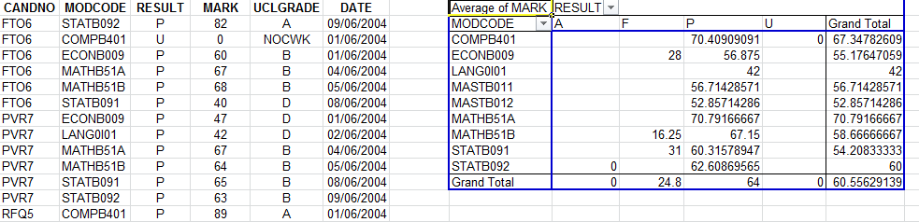

#### Adding additional calculations

To display more than one calculation in the Values area, add the same Field twice. Continuing with the example above, drag the Mark field onto the Values area again. The result is shown below, with Average and Count being shown for each Result. Count of MARK is effectively the number of exam results for each module that gained that particular result.

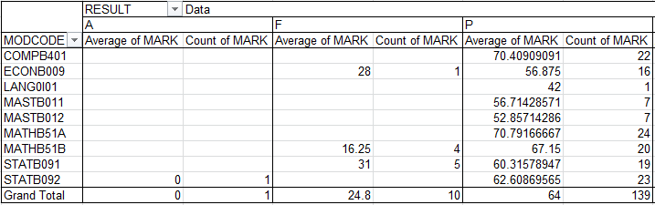

### Formatting values

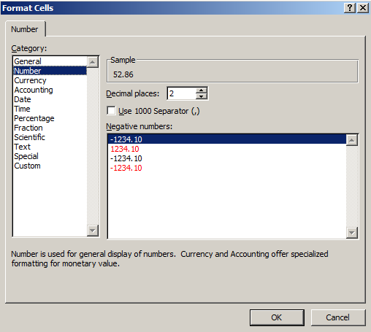

1. Display the **Field Settings** dialog box as shown above.
2. Click on the **Number Format** button.
3. Select the **Category** you want and set any options.  
   For example, select Number and enter the number of decimal places to display the data to.
4. Click **OK** and **OK** again and your cells will be reformatted.

### Displaying values as a percentage

1. Display the **Field Settings** dialog box as shown above.
2. Click on the **Show Values As** tab.
3. Select **Percentage of Row Total** or **Percentage of Column Total**

#### Example

In the example below, products ordered (paper and toner) are shown for each department as a percentage of the total for all departments. This is done by displaying values as a percentage of the column total.

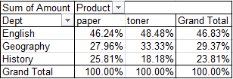

**Helpful hint**:

The Field Settings dialog box can be used to change the name of any Field in the PivotTable. For example, this can be used to change the name of **Dept** to Department.

## PivotTable Options

Pivot Table options control how data is displayed

1. Click on the **Options** button on the **PivotTable Tools Options** tab.  
   The **PivotTable Options** dialog box is displayed.
2. Useful options include:
   * **For empty cells show (**On the **Layout and Format** tab)   
     this enables you to display a default value (e.g. 0 or ‘No results’) where there is a blank.
   * **Show grand totals for rows/columns** (on the **Totals and Filters** tab)   
     Grand totals are displayed by default but can be removed if they are not meaningful. In the example of percentages, above, the Grand Total for each column will always be 100% so it is not meaningful and could be removed from the display.
   * **Refresh data when opening the file** (on the **Data** tab)   
     See *Refreshing* a PivotTable on page 9 for more details.

## Grouping data

Data can be summarised into higher level categories by grouping items within PivotTable fields. Depending on the data in the field there are three ways to group items:

* Group selected items into custom categories.
* Automatically group numeric items by a specific interval.
* Automatically group dates and times by a specific interval.

### Grouping selected items



1. Select the items you wish to group in a given row or column. Select adjacent items by clicking and dragging, or non-adjacent items by selecting each item whilst holding down the **Ctrl** key.
2. Click on the **Group Selection** button on the **PivotTable Tools Options** tab.
3. An additional column is created to the left (for row labels) or an additional row is created above (for column labels) and a default name (e.g. Group1) is given to the group.  
   The name can be changed in the **Custom Name** box in **Field Settings** or in the **Formula Bar**.
4. Use the **+/-** buttons to expand and collapse the group.

#### Example

In the example below, some modules have been grouped by subject. The **Statistics** group has been collapsed so that average results for Statistics are shown for both modules STATB091 and STATB092.

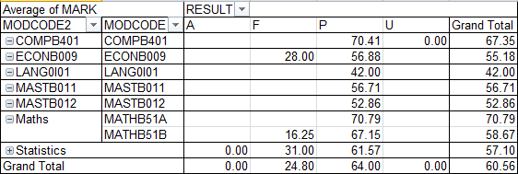

Note that MODCODE2 is now another field in the Row Labels area and can be added or removed like any other field.

### Grouping numeric items into ranges



1. Select a single field item in the PivotTable.

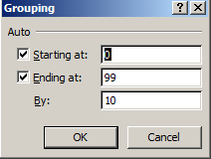

1. Click on the **Group Field** button on the **PivotTable Tools Options** tab.
2. Excel displays a dialog box in which it automatically enters a start and end number based on the highest and lowest values in your range. It also lists a number for the intervals to group by.
3. Select an appropriate interval and click OK.

#### Example

In the example below, marks are grouped in intervals of **10** so, for example, you can see that **1** candidate got between 40 and 49 marks in COMPB401 and **4** got between 50 and 59 marks.

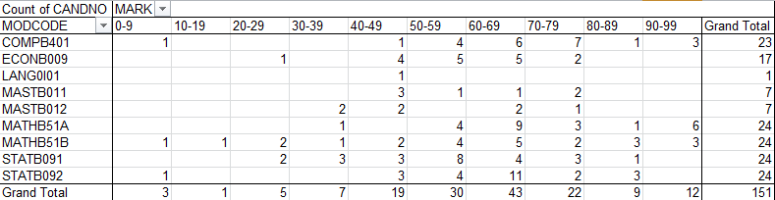

### Grouping date or time data

1. Select a single field item in the PivotTable.

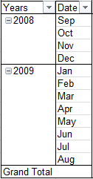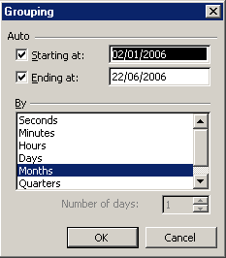

1. Click on the **Group Field** button on the **PivotTable Tools Options** tab.
2. Excel displays a dialog box in which it automatically enters a start and end date. It also lists a choice of intervals to group by.
3. Select an appropriate type of interval (e.g. Months) and click **OK**. If you select Days you can choose the number of Days. You can select more than one. For example if you select Months and Years, the data will be grouped by year and then displayed for each month as shown.

### Ungrouping

Click on the field you want to ungroup and click on the **Ungroup** button on the **PivotTable Tools Options** tab to ungroup specific custom groups, click on the name of the group and then the **Ungroup** button.

### Default grouping for multiple values

Note that grouping automatically occurs where you have more than one Field in the same area (Row or Column). In the example below, the Department and Term fields are both added to the PivotTable as Row Labels. By putting the fields in the order Department then Term, data is grouped by Department. Subtotals are automatically displayed for each grouping i.e. by Department.

Note that you can remove **Subtotals** in the **Field Settings** dialog box.

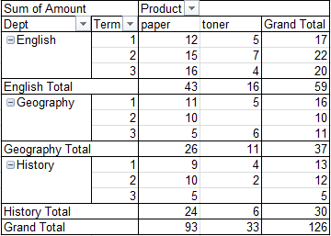

## Sorting and Filtering Data

Filtering allows you to display only certain data, either on the whole report or for a particular field. Sorting allows you to sort columns or rows alphabetically or numerically.

### Report filters

This allows you to filter all data out of a report if it has a value in a particular field.

1. Add the appropriate field to the **Report Filter** area.  
   The Field name will be displayed in a new area above the main part of the PivotTable.
2. Click on the drop-down arrow to the right of the word **(All)**.
3. Tick the **Select Multiple Items** check box if you want to view multiple values.
4. Click on or tick the values to include in the PivotTable.
5. Click **OK**.  
   A small funnel symbol will appear to show that the report is filtered.

#### Example

In the example below, only data from Terms 1 and 2are displayed in the PivotTable:

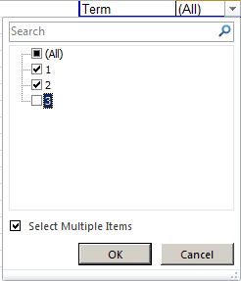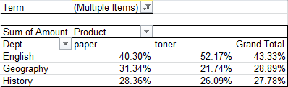

### Filtering row or column labels

To **filter** out (remove) a particular value from row or column labels:

1. Click on the drop down arrow next to the Field name.
2. Untick any items you wish to remove.
3. Select **Value Filters** to see more options such as **Top 10**.  
   Top 10 filters out a specific number of the highest values in the Value area.   
     
   In the example below, Top 10 on the Mark field is set to **5**so it displays only the exam results with the highest 5 values in the Grand total row i.e. the 5 exam results that appear most frequently amongst candidates:

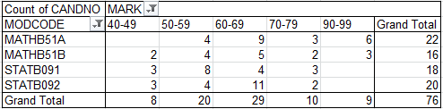

### Sorting row or column labels:

1. Click on the drop down arrow next to the Field name.
2. Click on **Sort A to Z** or **Sort Z to A** for text, **Sort Smallest to Largest** or **Largest to Smallest** for numeric data or **Sort Oldest to Newest** or **Newest to Oldest** for dates.

### Slicers

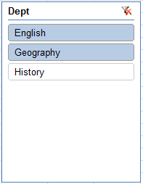

Slicers are a new feature in Excel 2010 and allow you to filter PivotTable data using a different interface. The results are exactly the same as the Report Filter and filtering Row and Column Labels.

1. Go to the **Insert** tab on the Ribbon and click on the **Slicer** button.
2. Tick the Fields you would like to use. These would be any fields you might wish to filter on.  
   A Slicer window for each field selected is displayed on the screen. Each unique value in that field is displayed.
3. Select one or more value to filter the field to show only those values. Multiple values can be selected by clicking and dragging over them or by holding down the **CTRL** key while selecting them.
4. Click on the Remove Filter button (top right of the Slicer window) to remove any Filters and see all values again.
5. To remove the Slicer (and any Filters created by it), click on the Slicer window and press the **Delete** key on the keyboard.

## Refreshing a PivotTable

When data is changed in the PivotTable source list, the PivotTable does not automatically recalculate. To refresh the table:



1. Select any part of the PivotTable.
2. On the Pivot Table Tools Options tab, click on the **Refresh** button.

**Helpful hint**:

**PivotTable Options** can be set to refresh data every time a spreadsheet is opened. See *PivotTable Options* on page 5 for details.

## Extending the dataset

If you add additional columns or rows to you will need to extend the data source of the PivotTable to include them.



1. Click on the **Data Source** button on the **Pivot Table Tools Options** tab.
2. Edit the range in the **Table/Range** box to include your entire dataset and click **OK**.

## Formatting PivotTables

Various options can be used to change the look of PivotTables. These can be found on the **PivotTable Tools Design** tab. You can apply a **PivotTable Style** and choose whether or not to have banded columns or rows (i.e. where rows or columns are coloured in alternate shades.

Note that buttons to add or remove **Subtotals** and **Grand Totals** are also available on the **Design** tab.

# PivotCharts

When you create a PivotChart, Excel automatically creates an associated PivotTable. If you have an existing PivotTable you can create a PivotChart based on it.

## Creating a PivotChart with a PivotTable

1. Click anywhere within your dataset.

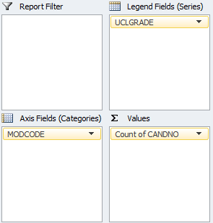

1. On the **Insert** tab, click on the **PivotTable** drop-down and select **PivotChart** from the list.
2. Choose the dataset and location of the PivotTable and PivotChart as you would to create a new PivotTable (see *Creating a PivotTable* on page 2).  
   A new blank PivotTable and PivotChart will be created.
3. Click and drag Fields from the Field List onto the different areas of the PivotTable in the usual way. The PivotChart and PivotTable will both be created simultaneously.

When the PivotChart is selected, the different areas of the Chart are defined slightly differently to the PivotTable areas. **Row Labels** are **Axis Fields (Categories)** and **Column Labels** are **Legend Fields(Series)** as shown right. The resulting PivotChart is shown below:

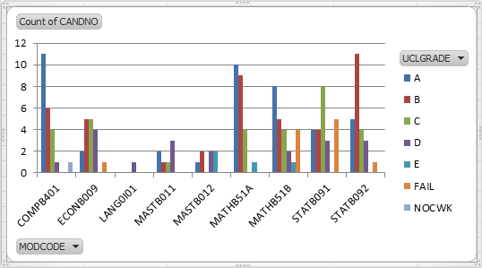

### Adding a PivotChart to an existing PivotTable

You can also add a PivotChart if you have already created the PivotTable:

1. Click anywhere on the PivotTable.
2. On the Insert menu click on a type of Chart in the Charts group e.g. Column and then select a particular style e.g. 2-D Column.  
   A PivotChart will be added to your existing PivotTable.

Note that some Chart types (for example Pie Charts) are not suitable for PivotTables because they can only show two variables. For example, a Pie Chart based on the above data would only display one UCLGRADE at a time.

### Formatting PivotCharts

PivotCharts can be formatted in the same way as any other Chart in Excel.